B”h

Write up 5.1

**Objective**:

To understand what this code is doing.

**Topics Covered:**

ida64

**Procedure:**

Here are the ideas on how to solve this challenge :D. Let’s perform static analysis on the exe file by using ida64 in windows machine (my favourite debugging tools).

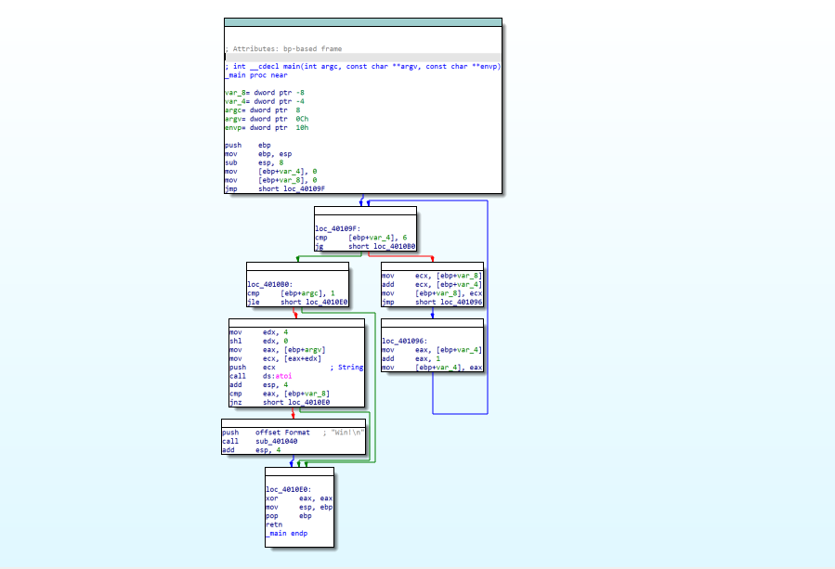

After glance through the assembly codes, it looks like there is a loop that runs 6 times. After the loop there is some if condition and if its true it prints “Win”.

I zoomed in on the loop:

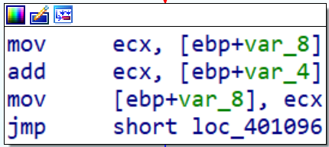

This loop adds every time the current value to the previous. So, what is actually happening it stores (1+2+3+4+5+6) = 21 in [ebp+var_8].

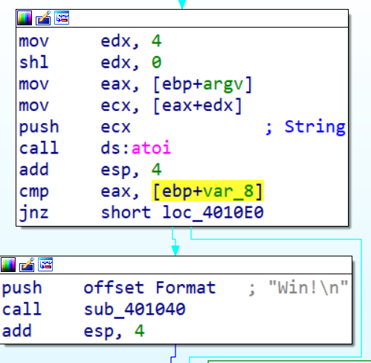

After that there is a compression between the input and 21.

And if the input is 21 it prints “Win”.

For conclusion, the correct input is 21.

That’s all for the write up, I hope you guys did enjoy my second ever write up on reverse engineering challenge. Cheers! I’m also hope that i can continue to publish some write up for the interesting challenges in the future.